DISCOVERY 2018!
SECOND ANNUAL REVIEW OF ARCHAEOLOGICAL DISCOVERIES IN ULSTER

Organised by the Ulster Archaeological Society and the Centre for Community Archaeology at Queen’s University

Friday 2nd November and Saturday 3rd November 2018

Programme

Friday evening, 2nd November 2018
Common Room, Elmwood Building, QUB & Lecture Theatre (Room OG-029), Elmwood Building, QUB

6.30 Conference Launch and Wine Reception.

7.00-7.20 Conference book launch: Life and Death in Medieval Gaelic Ireland. The Skeletons from Ballyhanna, Co. Donegal by Dr Catriona McKenzie and Professor Eileen Murphy. Four Courts Press.

7.20-8.00 Keynote Address: TBC

Saturday, 3rd November 2018
Lecture Theatre (Room OG-029), Elmwood Building, QUB

9.00-9.30 Conference Registration.

Session 1: Chaired by Dr Ian Meighan (Ulster Archaeological Society)

9.30-9.40 Conference Welcome: Professor Eileen Murphy (Head of Archaeology and Palaeoecology) & Ruairí Ó Baoill (President of the Ulster Archaeological Society)

9.40-10.00 Dr Mike King (Down County Museum)
What’s going up in Down?

10.00-10.20 Brian Sloan (Centre for Archaeological Fieldwork, QUB)
Unearthing Medieval Downpatrick.

10.20-10.40 Dr Catriona McKenzie (University of Exeter)
In sickness and in health'; the analysis of the Gaelic medieval skeletal collection from Ballyhanna, Co. Donegal.

10.40-11.00 Sarah Gormley (Centre for Archaeological Fieldwork, QUB)
Lignite bracelet production in the north of Ireland: a reassessment.

11.00-11.30 Morning Tea/ Coffee break.

Session 2: Chaired by Grace McAlister (Centre for Archaeological Fieldwork, QUB)

11.30-11.50 Dr James O’ Neill (Ulidia Heritage Services)
'This land of ire’: The Landscape and Archaeology of Tyrone's Rebellion.

11.50-12.10 Ruairí Ó Baoill (Centre for Archaeological Fieldwork, QUB and Ulster Archaeological Society)
Excavations at Mountjoy Fort, Brocagh, Co. Tyrone.

12.10-12.30 Dr Heather Montgomery (Archaeology and Palaeoecology, QUB)
For Forts Sake- Comparing Grey Point Fort, Co. Down, and Leenan Head, Co. Donegal, Coastal Defences.

12.30-12.50 Dr Liam Bradley (Monaghan County Museum)
From the Stoney Grey Soil – The Archaeological Collections of Monaghan County Museum.

12.50-1.00 Q & A for morning session.

1.00-2.00 Lunch

Session 3: Chaired by Malachy Conway (National Trust for Northern Ireland)

2.00-2.20 Dr Harry Welsh (Ulster Archaeological Society)
The activities of the Ulster Archaeological Society’s Field Survey Group during 2018.

2.20-2.40 Mark Lusby (Friends of the Derry Walls and PhD, QUB)
Rediscovering the Derry Walls - how the Plantation City looked in 1619.

2.40-3.00 Stephen Gilmore and Tom McCrudden (Northern Archaeological Consultancy Ltd)
Investigations at a Late-nineteenth century munitions tunnel and railway at Carrickfergus Castle, Co. Antrim and Excavations at a multi-period site at Carryduff, Co. Down.

3.00-3.20 Marie-Therese Barrett (PhD researcher, QUB)
Drumclay, Co. Fermanagh: examining a crannog’s response to environmental, socio-political and economic changes at an annual resolution.

3.20-3.35 Dr Ian Meighan (Ulster Archaeological Society)
Important Geological Discoveries from Ulster Monuments.

3.35-4.00 Afternoon Tea/ Coffee break.

Session 4: Chaired by Dr David Bell (Visiting Research Fellow, QUB)

4.00-4.20 Barrie Hartwell (Ulster Archaeological Society)
Ballynahatty Prehistoric Landscape - new evidence from aerial survey.

4.20-4.40 Dr Patrick Gleeson (Archaeology and Palaeoecology, QUB)
Remote sensing Emain Macha: recent geophysical discoveries at Navan Fort.

4.40-5.00 Dr Cormac McSparron (Centre for Archaeological Fieldwork, QUB)
The enigma of aceramic periods in the Irish Late-Prehistoric and Early Historic eras.

5.00-5.20 Andrew Gault (Historic Environment Division, Department for Communities)
Unearthed- New Discoveries in Development-Led Archaeology in Northern Ireland.

5.20-5.30 Q & A for afternoon session.

5.30 Conference concludes.
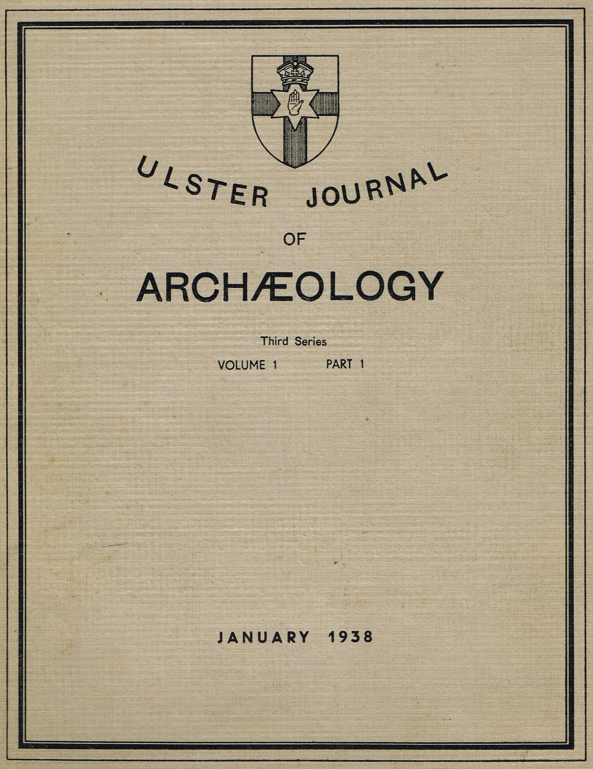

1938-2018
80 YEARS OF THE ULSTER JOURNAL OF ARCHAEOLOGY
(THIRD SERIES)

